**DAILY ONLINE ACTIVITIES SUMMARY**

|  |  |  |  |  |  |  |  |  |
| --- | --- | --- | --- | --- | --- | --- | --- | --- |
| **Date:** | **27/05/2020** | | | | | **Name:** | **AKASH S** | |
| **Sem & Sec** | **4TH&A** | | | | | **USN:** | **4AL18CS004** | |
| **Online Test Summary** | | | | | | | | |
| **Subject** | | **OBLECT ORIENTED CONCEPT** | | | | | | |
| **Max. Marks** | | **30** | | **Score** | | | **28** | |
| **Certification Course Summary** | | | | | | | | |
| **Course** | **JAVA PROGRAMMING** | | | | | | | |
| **Certificate Provider** | | | **GREATLEARNING** | | **Duration** | | | **3.5 HOURS** |
| **Coding Challenges** | | | | | | | | |
| **Problem Statement:1:**  **Write a C Program to sort an array of integers in ascending order and display the sorted array and Number of passes performed for sorting.** | | | | | | | | |
| **Status: executed** | | | | | | | | |
| **Uploaded the report in Github** | | | | | **YES** | | | |
| **If yes Repository name** | | | | | **https://github.com/akashacharya786/lockdown-c-coding** | | | |
| **Uploaded the report in slack** | | | | | **YES** | | | |

Online Test Summary: 18CS45 online test was scheduled from 9:15am to 9:45 am. The portion for the IA was 5th module. The question were MCQ type There were 30 question 1 mark respectively duration is 30 minutes .The score I received was 28/30.

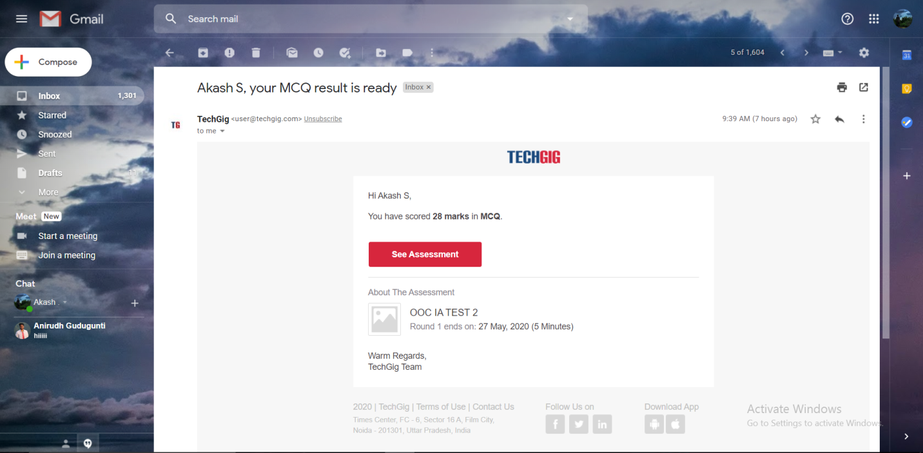

Online Certification course:

Name of the course: java programming

Certificate provider :great learning

Today I have successfully completed a java programming course.

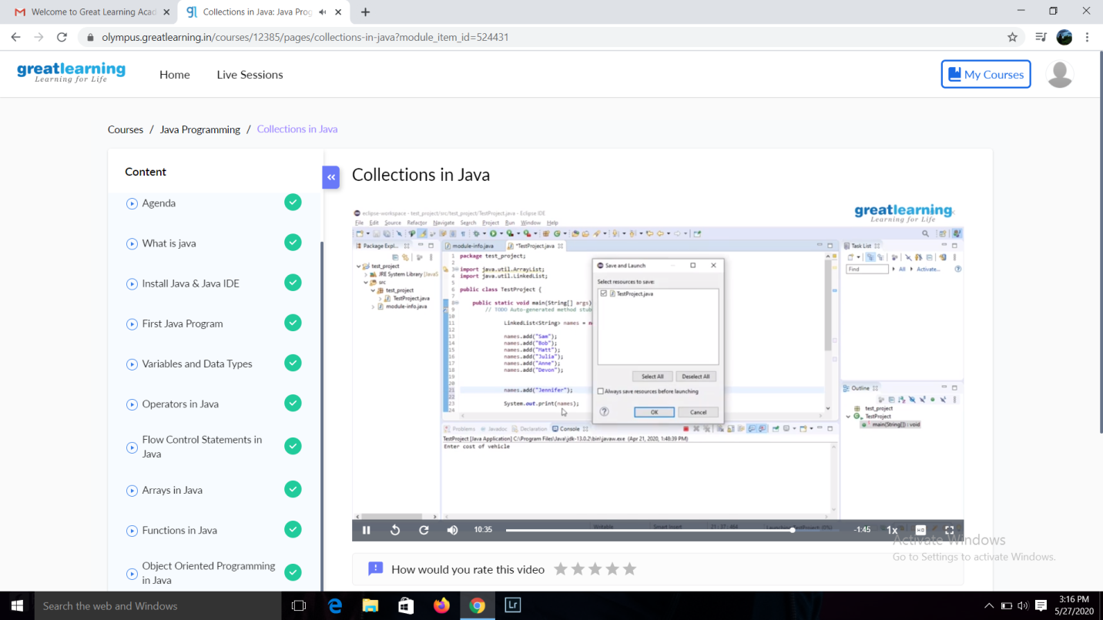

**This is the snapshot of the course.**

Online Coding summary:

1. Write a C Program to sort an array of integers in ascending order and display the sorted array and Number of passes performed for sorting.

